Tikvah Program at Camp Ramah Darom

Employment Opportunities working with Special Needs Campers
We are seeking highly qualified, compassionate, and energetic camp counselors to be a part of the Tikvah Staff at Camp Ramah Darom!

Ramah Darom’s Tikvah Program is a summer experience for campers diagnosed with
Neurodevelopmental Disorders such as Autism Spectrum Disorder, Down syndrome, Intellectual
Disability and Communication Disorders. Tikvah is focused on providing a traditional, immersive, Jewish summer camping experience to Jewish children with disabilities. The program is fully integrated into a community that is steeped in Jewish celebration, learning, and ritual. Campers will benefit from meaningful formal and informal Jewish learning opportunities specifically designed to foster their emerging Jewish identity. Through individualized programming supported by highly-skilled staff, campers in the Tikvah program will build friendships, gain a sense of autonomy, develop independent living skills, learn problem-solving skills, have fun, and grow as members of the Ramah Darom community.

Tikvah Counselors:
- Participate in all camp activities organize and manage daily schedules and activities.
- Facilitate camper friendships.
- Provide a positive and enriching community where campers can build self-confidence, self-esteem, and independence as well as strong group relationships.
- Ensure that campers’ daily needs are met.
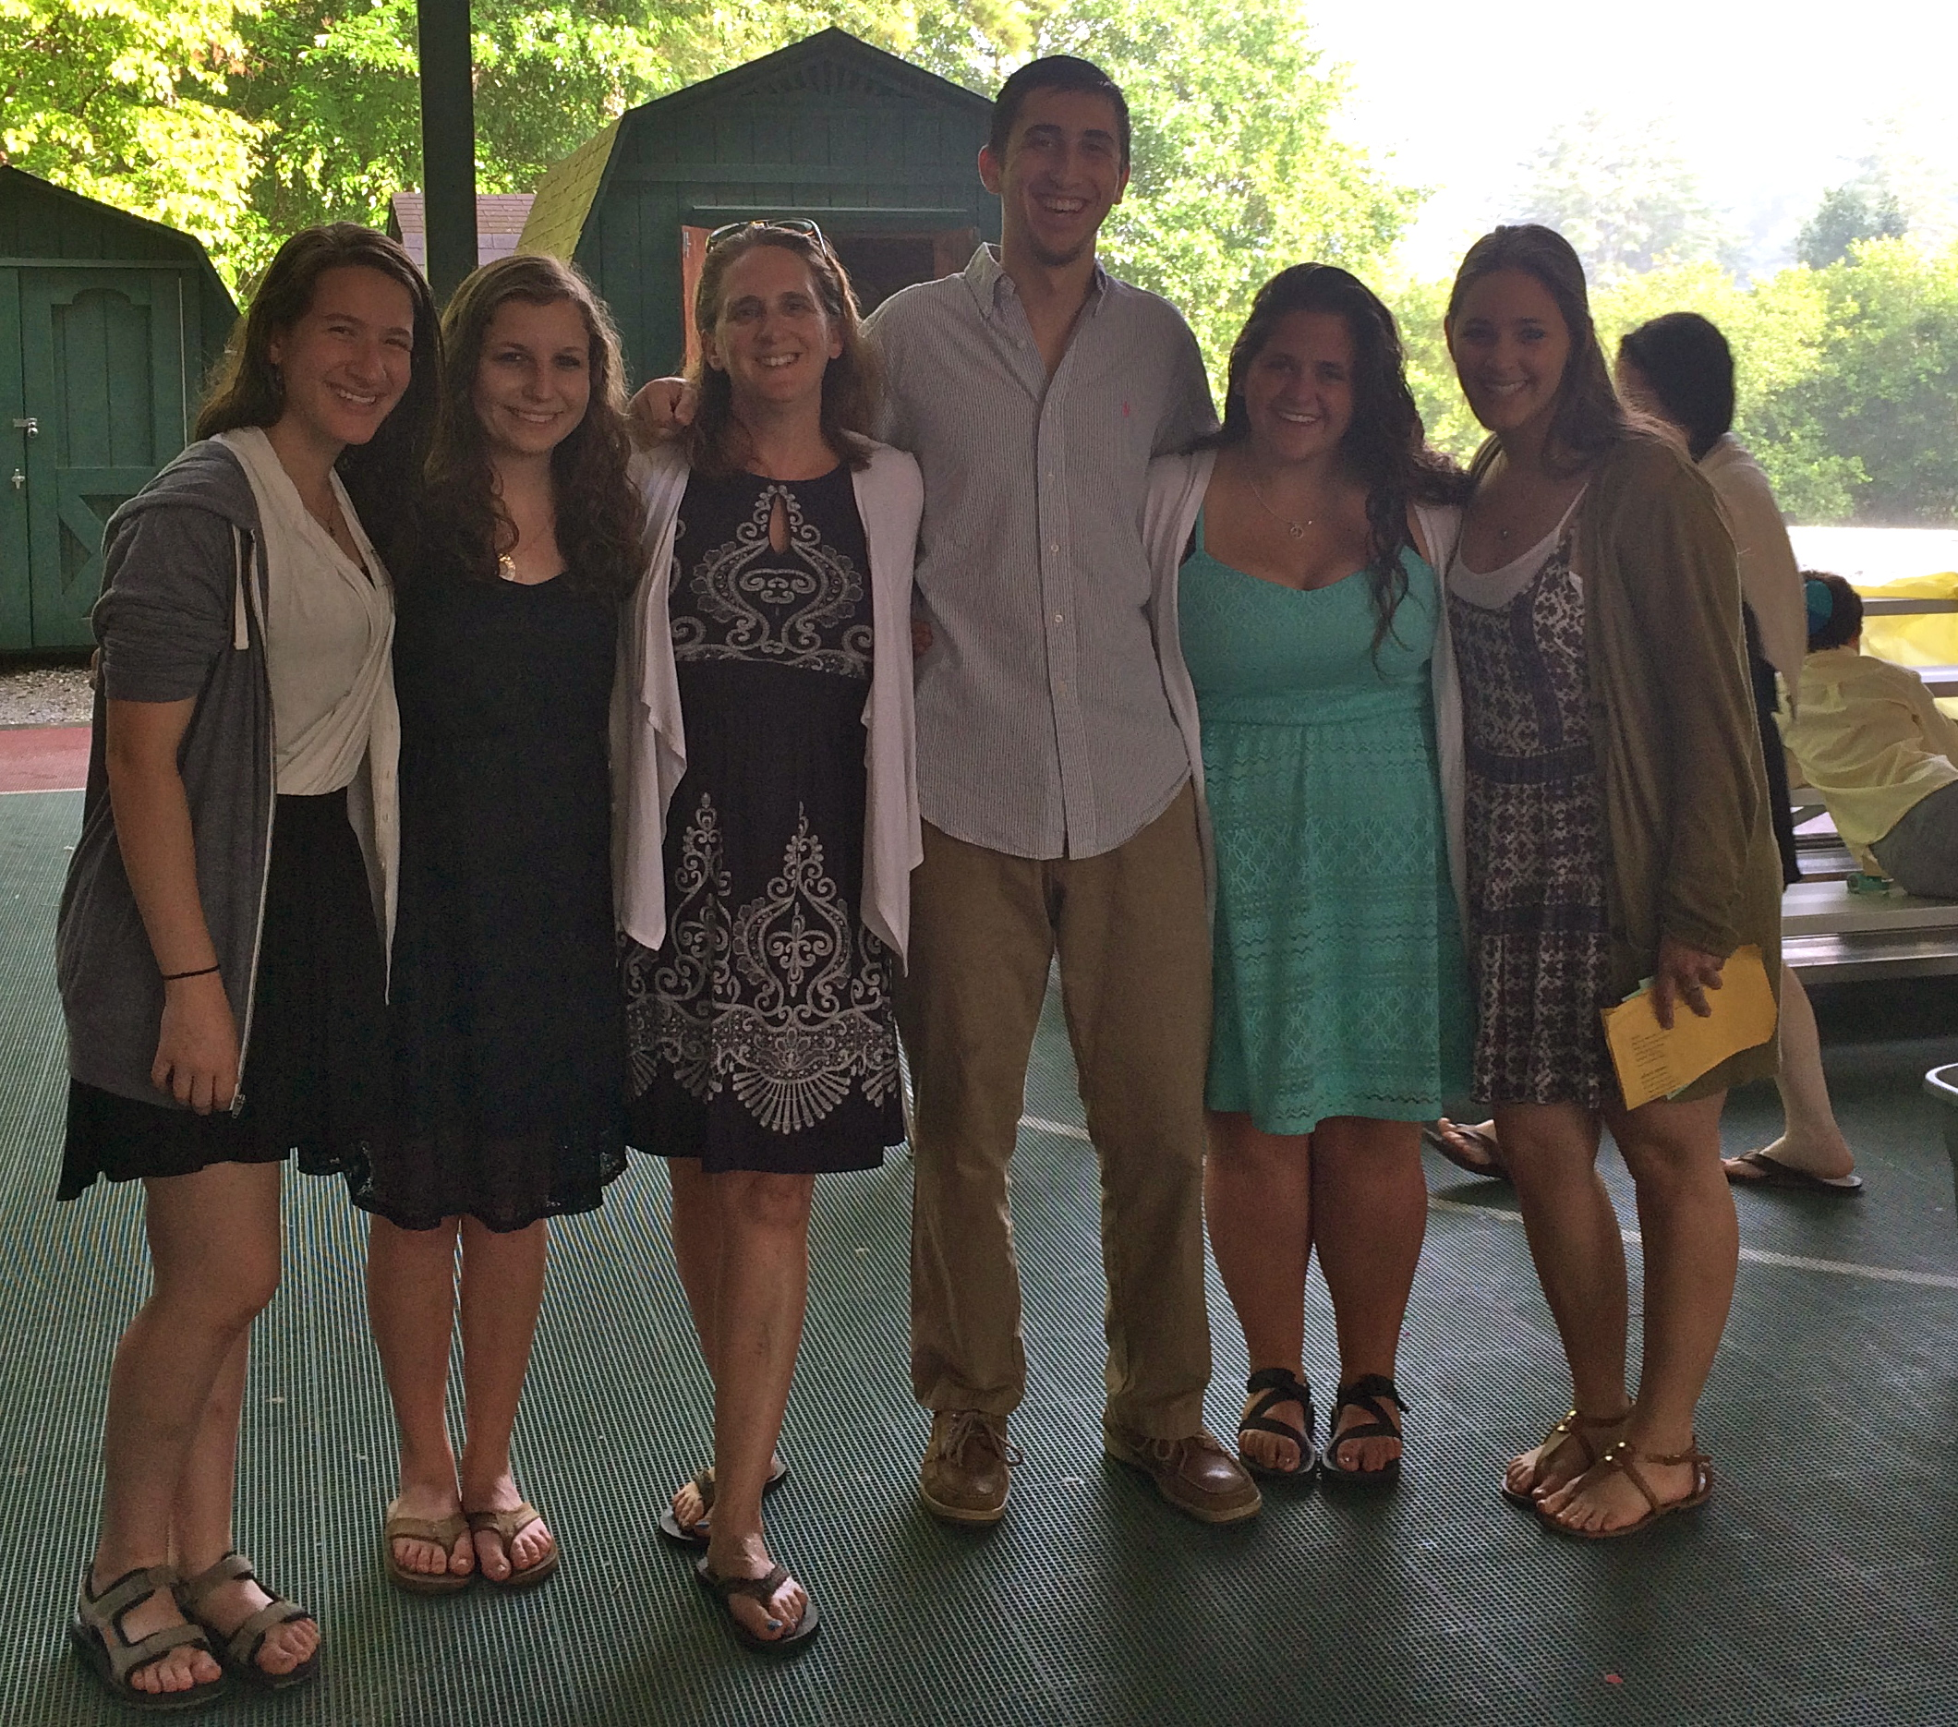

Why work for Camp Ramah Darom?
- Experience the magic of Camp Ramah Darom
- Gain skills and confidence
- Be a part of a welcoming Jewish community.
- Develop programming and management skills.
- Grow as an individual.
- Be a part of an amazing supportive team.
Experience the joy of knowing you are making difference in the life of campers and their families!
Requirements:
- Preference is given to those with an educational background in education, recreational therapy, occupational therapy, psychology, social work and related mental health fields.
- Experience and interest in working with youth with special needs.
- Demonstrate leadership qualities and be able to manage and facilitate small and large group activities.
- Desire and ability to work with children, adults and peers in an overnight camp setting.
- Demonstrate initiative, enthusiasm, creativity, flexibility, professionalism, sound judgment, and a caring personality.

Ready for camp?
Candidates are encouraged to apply as soon as possible as applications are reviewed and accepted on a rolling basis. Please complete the online application http://camp.ramahdarom.org/staff/job-opportunities/ and select “Tikvah Counselor” for the position you are applying for. If you have questions, please contact Dr. Audra Kaplan at akaplan@ramahdarom.org.
Summer 2017 Sessions Schedule:
2,4, and 8-week sessions
June 13-August 7
Part and full summer positions are available.

